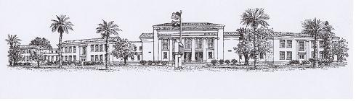

CHANDLER HIGH SCHOOL

350 N ARIZONA AVE
CHANDLER, AZ 85225
480-812-7700 PH /812-7720 FX
Dear Parent,

My name is Eric Richardson and I would like to take this opportunity to welcome you and your daughter/son to my classroom. I will be teaching several sections of World History at Chandler High School and I look forward to enhancing and enriching your child’s educational experience this year. Furthermore, I am eagerly anticipating hearing from you concerning your child’s progress in class. I will make every attempt to keep you up to date on your child’s performance throughout this year.
Attached you will find a copy of my class syllabus. In it you will find my grading policy, assignments, topic coverage, discipline policy and behavioral expectations. If you have any questions regarding any part of the syllabus, policies or procedures, please feel free to contact me at the phone number or email address listed below. I can be reached at the school (480) 812 – 7772 or through email at richardson.eric@cusd80.com.
To enhance our ability to communicate effectively, I need some contact information from you and your student. Please complete the questionnaire below and have your student return it to class by Monday July 27, 2015. Also, you are cordially invited to OPEN-HOUSE, THURSDAY JULY 30th. Your student will receive 10 points extra-credit for your attendance. These activities are considered your students first assignments.

Thank you in advance for your cooperation

Sincerely,

Eric V. Richardson

Students Name: _______________________________________________________

Parents Name: ________________________________________________________

Address: ____________________________________________________________

Phone # (HP) ______________(BP)__________________(CELL)_______________

Parents Email: _______________________________________________________

Students Email: ______________________________________________________

(Parent Signature): X __________________________________________________

(Student Signature): X _________________________________________________

